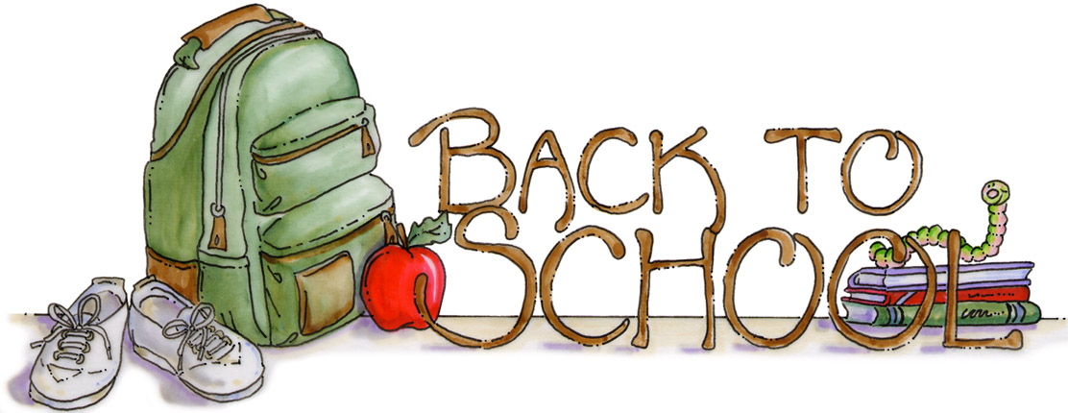

***Supply List for 6th Grade***

***at Oasis Elementary 2024-2025***

* 4 pocket folders (Math, ELA, Science, & Social Studies)
* Loose-leaf notebook paper (continue to supply as needed)
* Box of pencils sharpened (continue to supply as needed)
* Ballpoint pens–black or blue (no click pens please)
* Erasers/pencil top erasers
* Pencil bag
* Scissors
* Colored pencils
* Glue sticks
* Highlighters
* Two large boxes of Kleenex (we are always running out)
* Dry erase markers (continue to supply as needed)
* Hand sanitizer
* Wet wipes (to clean desks and work area)
* 3 Composition books
* Earbuds/Headphones (***not*** Bluetooth; the student laptops will not connect) This is very important—we use headphones a lot!

**THANK YOU!!!**

C:\Documents and Settings\mthalacker\Local Settings\Temporary Internet Files\Content.IE5\IEHV9AT2\MC900110872[1].wmf

***6th grade is going to be a fantastic year!!!***